Where Australia’s permanent migrants come from
NEW data shows where Australia’s permanent migrants are really coming from — and you might be surprised by the results.
Charis Chang with wires July 20, 20182:22pm
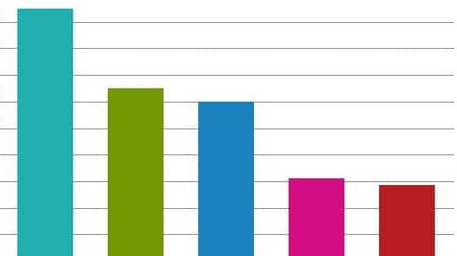
Where do Australia's migrants come from?Source:Supplied
NEW figures have revealed where Australia’s two million permanent migrants have come from since 2000.
The Australian Bureau of Statistics has released new data that identifies India, England and China as some of the top birth countries of the country’s migrants.
It has also revealed that more than half of them are buying or trying to buy their own homes.
There were about 2.2 million permanent migrants in Australia in 2016, who arrived between January 1, 2000, and August 9, 2016, according to the 2016 Australian Census and Migrants Integrated Dataset.
The report links data gathered from the 2016 Census and from the Department of Social Services.
It found 58 per cent (1.2 million people) had been granted a skilled visa, 32 per cent (683,603) entered via the family stream and just 10 per cent (214,656 people) were on humanitarian visas.
The data also revealed where the migrants were coming from.
For those coming to Australia on the skilled visa, the top country of birth was India (19 per cent), followed by England and China.
When it comes to family migrants, the top country of birth was China (14 per cent), then England and India.
For those on humanitarian visas, Iraq was the top country of birth (18 per cent), followed by Afghanistan and Myanmar.
About 78 per cent of those applying for humanitarian visas were offshore applicants. They were the most likely category of migrants to apply for their visas overseas, compared to those on the family stream (72 per cent) and skilled migrants (60 per cent).
The figures also revealed that about 54 per cent of permanent migrants aged 15 years and older, were buying or owned their own home.
Migrants in the family stream were the most likely to own their home outright (14 per cent), followed by skilled migrants (8 per cent) and humanitarian migrants (4.7 per cent).
The data comes as migration numbers in Australia hit a 10-year low.
Liberal senator Dean Smith this week called for a review into Australia’s population policy as the nation approached 25 million residents.
But Prime Minister Malcolm Turnbull said Australia’s immigration and population growth was constantly under review.
He also said the Federal Government was building new projects, like the Western Sydney Airport, to meet rising demand.
“We are getting actively involved, we’re building infrastructure ourselves,” he told 3AW radio in Melbourne.
Home Affairs Minister Peter Dutton said last week that the annual intake of permanent migrants fell by 20,000 last year to 162,000, with both skilled and family visas down.
This was the lowest in a decade and attributable to tighter vetting procedures, he said, with dishonest applications in the Government’s crosshairs.
“We’re making sure that people who do become part of our Australian family are coming here to work, not to lead a life on welfare,” he told reporters in Brisbane.
“If you have a robust migration program like we have, and you are assured of the entrants coming in through the program, that they are going to be productive, that they are going to work hard, they aren’t going to lead a life on welfare … you will see increased economic benefit.”
Immigration remains a talking point in Australia, amid concern about jobs and overcrowding in major cities.
The Labor Opposition welcomed the drop in migration numbers but said the Government must do more to help those in offshore detention, where hundreds still remain in limbo.
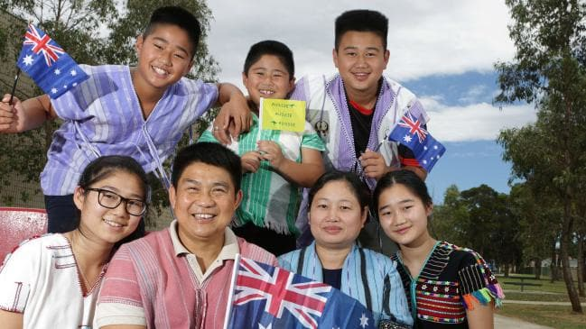
A Sydney family from Myanmar, who arrived as refugees, are now proud Australians.Source:News Corp Australia
“We have seen suicides, we’ve seen a range of mental health conditions being identified and the Government has got that element of the policy wrong,” senior Labor MP Anthony Albanese said.

Migrants trying to enter Australia by sea have been sent to camps on Papua New Guinea’s Manus Island or on Nauru in the Pacific for processing, with even those found to be genuine refugees barred from Australia.
The policy has been criticised by rights groups as well as the United Nations, which has slammed Canberra’s harsh treatment of asylum-seekers who arrive by boat.
Dutton defended the policy as a deterrent against people-smugglers and added that it allowed Australia to offer refuge to those seeking asylum through legitimate channels.
“Last year we had the biggest offshore intake (of refugees) into our country that we’ve seen in decades,” he said. “We did that because we’ve secured our borders.”
Australia’s humanitarian intake — which it excludes from its permanent migration count — was close to 22,000 for its 2016-17 program, which included a special assistance provision for 8200 people affected.
https://www.news.com.au/finance/economy/australian-economy/where-australias-permanent-migrants-come-from/news-story/f5ec188ed1c276727566215bd0be4705
he/economy/australian-economy/where-australias-permanent-migrants-cohttps://www.news.com.au/finance/economy/australian-economy/where-australias-permanent-migrants-come-from/news-story/f5ec188ed1c276727566215bd0be4705me-from/news-https://www.news.com.au/finance/economy/australian-economy/where-australias-permanent-migrants-come-frohttps://www.news.com.au/finance/economy/australian-economy/where-australias-permanent-migrants-come-from/news-story/f5ec188ed1c276727566215bd0be4705m/news-story/f5ec188ed1c276727566215bd0be4705story/f5ec188ed1c276727566215bd0be4705

